The March to the Mart
A true David vs. Goliath Story About Entrepreneurial Creativity and Guts
By Ken Walker
for Draper

Preface
In July of 2017, Artisan Electronics Group opened a 1,105-square-foot showroom on the 14th floor of Chicago’s iconic Merchandise Mart. At 4.2 million square feet, the Mart is the largest commercial building in the United States, a title it has held since it was completed in 1931. Upon its completion, it was the largest building in the world, spanning two full Chicago city blocks. It is estimated that 10,000 people work in the building and more than 25,000 pass through its doors daily. It is in many ways a city unto itself, a notion supported coincidentally by the fact that it has its own zip code.
Our “March to the Mart” story cannot be told without the preface, including a significant reference to the shear enormity of the Merchandise Mart because the “objective to conquer” was a task made larger as a direct function of the size of the Goliath itself.
As incredible as it seems, this beautiful and massive architectural wonder began life as a warehouse for Marshall Field & Co. It was for all intents and purposes a giant box with a spectacular art deco facade. There is a distinct possibility that the Mart may have been overbuilt, but this was a very historical period in American architecture, and there was a certain level of not-unspoken competition between architects, their patrons, and cities to design and build what must have been unfathomable masterpieces at the time of their creation. Today, these buildings remain as a handful of the greatest wonders ever built in the modern history of the world. To think that the Chrysler Building and Empire State building in New York, along with the Chicago Board of Trade Building and the Merchandise Mart in Chicago were all completed within less than 12 months of each other is nothing short of astounding, particularly given its timing right in the heart of the Great Depression. All these amazing buildings have won more design awards than can be counted, but in the contest of size, there could only be one winner and that was Marshall Field’s Merchandise Mart.
Not long after opening, however, Marshall Field & Co. came to realize that the current state of supply and demand in the consumer marketplace did not require 4 million square feet of warehouse space for the storage and distribution of their goods. The building became filled with many different forms of the mercantile trade, most notably with the wholesale fabric and furniture trades. To this day, roughly 50% of the building’s rentable space is dedicated to housing some of the most distinguished and fashionable furniture and appliance brands in the world. The collective gathering of these showrooms is what has made the Mart recognized as both the largest and most prestigious design center in the world.
Originally, the building was a trade-only place of commerce with highly restricted access to the showroom floors. There were guards at the elevators and one had to have a “Mart Card” to even get on the elevator. The current owners of the Mart made a huge shift in business strategy in 2010, opening the showroom floors to the general public for the first time in the history of the building. For some, old habits die hard, and eight years after opening the showroom floors to the consumer, many of the showrooms around us still will not sell directly to the consumer. They can look, but they can’t buy!
As a design center catering to the luxury residential market for both trade and consumer, the Mart boasts a tenant/showroom roster that is the absolute who’s-who of the very finest brands in every category and aspect of the luxury residential home market. Folklore has it that the Sultan of Brunei, along with his design team and a few of his wives, decorated his entire palace with a one-week visit to the Mart and he never left the building. Every imaginable category, for every imaginable need was represented within this design Mecca, including the finest kitchen appliances, the supplest furniture and rugs, wall coverings and floor coverings, lighting and beyond. Every category, save one. Prior to Artisan Electronics Group opening their 1,105-square-foot showroom in this 4.2 million square foot colossus, there has never been any representation of any business related to any aspect of the consumer electronics industry. That the first to do so was a small, family-owned integration firm “from the suburbs” is what this David vs. Goliath story is about.
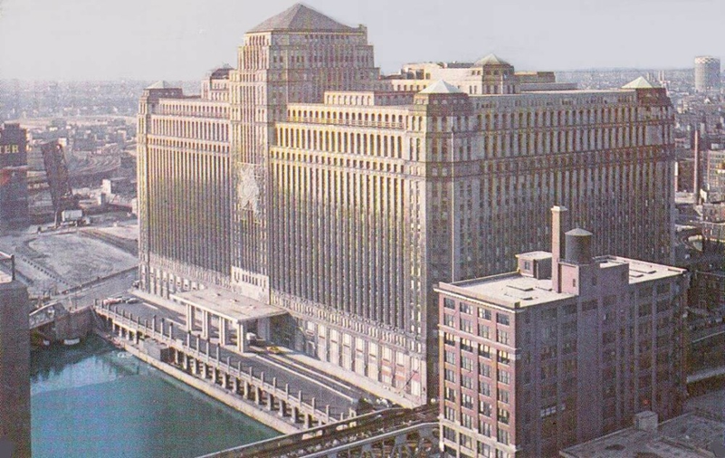

Who is Artisan Electronics Group?
What is now Artisan Electronics Group (AEG) came to life in 2003 as Sound Design Systems (SDS). Its founder and owner (and author of this paper), Ken Walker, had at that time recently concluded a 20-year career in the Fortune 500 broadcasting business, the majority of which was spent at CBS in network advertising sales and sales management. At the time of the departure from that career, I felt that 20 years had been enough and I was looking for a career path that might involve entrepreneurship. For as much as I did not see a clear path toward what that might be, I was very fortunate to have the good counsel of others close to me who suggested I pursue something for which I had enjoyed a lifelong passion.
Without knowing the nomenclature, I had been a “two channel guy” since I was 12 years old. Growing up in a small town in Iowa, where the morning newspaper was still delivered by enterprising young boys on bicycles who rode their routes before the sun came up, the first thing I bought when I had real cash in my hands was an honest-to-goodness stereo. Pulling speaker wire in the family home at age 14 seemed like a perfectly natural thing to do. I had always been good with tools and had a good mechanical sense from a very young age. Although I was decades away (many decades) from properly “cutting in a box,” I had no problem blasting a hole in a wall or a floor to create a wire pat and then just move furniture around a little bit to conceal my handiwork. As a true audio junkie, in the years that passed from age 14 to 44, I had cumulatively pulled a considerable amount of speaker wire (12 AWG!) in my own homes and those of family and friends, to create sound systems of relatively simple infrastructure needs.
I knew just enough to know that from a design and performance standpoint—more speakers are always better—and my longtime appreciation for high-quality sound reproduction had made me a reasonably knowledgeable speaker aficionado. I understood from early on that good speakers perform their best with good amplifiers. I learned about impedance the hard way, but I was a quick study by hobbyist standards.
In 2003, the luxury new construction market in Chicago was booming. I launched Sound Design System with a business strategy of building large-scale, high-fidelity sound systems in the big houses that were popping up all around us in Chicago’s far western suburbs. With no professional experience in the category, no contacts in the industry, and only my own piggy bank to work with for startup capital, I believed that my unbridled enthusiasm and passion, along with the business acumen I had gained from a successful Fortune 500 background just might be enough to make a go of it.
Fortunately, I was not completely alone in that I had pitched the idea to a longtime friend and fellow electronics junkie by the name of Mike Gryzik, who had operated his own residential remodeling business for more than 20 years and had helped me understand the concept of “creating wire paths” for some of the more adventurous projects I had undertaken in my own home. I had already spent a considerable amount of time in attics and crawl spaces, but my working knowledge of the more structural aspects of home construction still had a lot of room for growth. My thought was that I would try to secure Mike’s services as a subcontractor to help me and teach me more about the installation side of things for when I secured projects that were beyond my current installation capabilities. Mike not only liked the idea, he loved the idea, and asked if he could come into the company as an equal partner.
We joined CEDIA from day one and believed that the combination of my executive sales background and Mike’s experience as a skilled residential contractor could be a unique and potentially prosperous pairing of skills. Our combined sense of passion and commitment made us believe that we could pull the loose ends together and we found traction immediately. Before we had been in business one year, we had completed a substantial system in a large beautiful home, and through my own, personal public relations efforts, were able to have the project featured in two issues of Electronic House magazine.
Things were going along swimmingly. The idea was working. I was wholly engaged in the learning process, from the system design side, as well as the enormous new world of product knowledge (both of which continue to be a huge part of my passion, 15 years into the pursuit). I knew that Mike was a skilled and detail-oriented trim carpenter and his skills really came to shine in our category. We quickly earned a reputation for creating great sound and extremely tidy installations. We were busy and loving what we were doing.
In starting my own business, one of my primary desires was the notion that I could succeed or fail based upon my own ability to make that happen, or not. In my final five years in the broadcasting business, I had seen so many plot twists in the form of mergers and acquisitions and restructurings, and it had really made my head spin. With Sound Design Systems, I believed that if it was completely up to me; I was either going to get it done, or go to work for UPS and deliver the electronics for other people’s projects.
Just like a lot of other people, I didn’t see 2008 coming. I never imagined that an entire industry could be thwarted so stunningly and realized quickly that I was not the master of my personal universe after all.

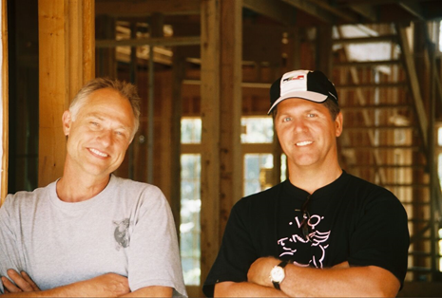

Becoming AEG
The enterprise formerly known as Sound Design Systems did not see the economic downturn of 2008 coming with any greater foresight than anyone else. We thought we were just starting to really figure it out, believing we had a formula that had legs to it. When the world around us began to collapse in 2008. We were fortunate to have secured several outstanding projects that would take us through August of 2010.
Upon completion of the last of these large projects, the cartoon anvil hit us squarely on the head and absolutely flattened us. We were instantly on the brink of extinction. Mike went back to his own remodeling business, and I scratched and clawed for all the one-man projects I could find, just to be able to claim that SDS was still in business. There is no stronger statement in the telling of this story than to say that if it were not for my wife Georgeann’s faith in me and my dreams, and the ability to support us through extremely challenging times, this tale with a happy ending would not be told.
We had to make a shift and needed to understand where our competitive capabilities could create a path for the future. For SDS, our business model seemed to have reached its end of life, and we were clearly at the “adapt or die” part of our story. Of our brethren that survived the collapse, many had shifted to light commercial projects to change their market position. In a city like Chicago and its surrounding population base, there has never been a shortage of new restaurants and bars popping up, all needing electronics of one sort-or-another.
Making the shift to light commercial projects just didn’t feel like the right move for us, for a couple of reasons. Firstly, I’m just not a “monkey-see monkey-do” sort of person. I believed that if everybody I knew was making a migration to light commercial, the category was going to become crowded very quickly. I also knew that these types of projects were often highly commoditized with low margins. Most importantly, along with my passion for electronics was a deep seated and genuine appreciation for great interior design. From a business standpoint, SDS had already expanded our offering to include things like lighting control and motorized shading. Even though AV was still the locomotive that pulled the train, I was beginning to feel like being one-of-a-million integration companies who begin the name of their business with the word “sound” was a little bit limiting.
Additionally, and of equal significance was what we had been doing in recent years to evolve our skills as masters of concealment and we had become very good at it. We believed that it was a core pillar that we could use at the very least as a pivot point. For years, I had been flattered to have many of my clients tell me that I was an artisan within my trade. With virtually no projects to keep us busy, we took our first vacation in many years and went to Mexico for a week. With plenty of sunshine, tropical breezes and tropical drinks, along with no phones, internet or other distractions, we pondered our future and threw ideas into the pool, the sky, and the ocean, and came home with the name Artisan Electronics Group and a plan to build on.

Joining ASID
Upon our return from Mexico, the very first item on the agenda was to secure the web domain for Artisan Electronics Group, and fortunately it was available in the “dot com” version. We latched onto it and considered that to be a good sign. From there the transition from Sound Design Systems to Artisan Electronics Group began and it was a very gradual process. By mid-summer I had a new business card and a reasonably respectable holding page for our website.
In the summer of 2012, we put our bullseye on Chicago’s design community. We had to have a direction and given that luxury new construction was no longer a category that existed and we did not want to go light commercial, it seemed like the only logical choice left was the design community. In many ways, we had already started to “drip” our message that direction, but I still felt that there was too often a disconnect when I contacted even the small suburban designers under the name “sound.” If there was one thing about that I felt certain from very early on in the pursuit of designers, it would be that they are generally very uninterested spending any time talking about sound.
Another important influence at this time had been that last big project we had completed in 2010—a spectacular large-scale gut-remodel. That job was the first time that I had ever worked closely with a designer and homeowner on so many aspects of intelligently and creatively integrating a large-scale electronics system into the overall design scheme of the home. It was nothing short of sublime. It was an eye opening, stimulating and challenging undertaking, and I thoroughly enjoyed the process. At year seven in business, it was our ultimate showcase project and a perfect addition to our portfolio to help us build a presentation for our strengths on the design side of things.
I had been contemplating joining the American Society of Interior Designers (ASID) since completing that project, but held off while we sorted out how we were going to finesse our change in direction. It had been my thought that to have joined ASID as Sound Design Systems and then at some time in the not too distant future change to something else might not be the best way to break into a new marketplace.
By August of 2012, we were convinced that the move to truly becoming Artisan Electronics Group was going to be the right path for us. We joined ASID Illinois, a move which history will show was very meaningful for our business and our future. Once we had joined, people told us, “You have to get involved. You can’t just pay your membership dues and expect that designers will suddenly start doing business with you.” We got involved. We’re still involved.

ASID Illinois Design Summit | March 2013
The annual Design Summit had been a big event on the ASID Illinois’ event calendar for many years. By its simplest definition, it was a one day mini trade show,” whereby the chapter would rent a small portion of the Merchandise Mart’s enormous 7th floor exhibition space and sell the display space to the Chapter’s Industry Partner Community to introduce themselves and their wares to the chapter’s designer members. There were always CEUs on offer as an additional draw to bring in designers. There’s also never an event in the design community that doesn’t wind down with a networking event, which is for sure another term for cocktail party. At this point in time, we were a little more than six months into our ASID membership and thought that displaying at Design Summit could be the perfect way to introduce ourselves to a significant number of designers. We decided to go for it.
We had never participated in any trade show or consumer home show of any sort, so this was a first for us. Task one was to secure a specific space on the show floor, and we were thrilled that the space next to Lutron was available, which we thought was another positive sign for us. We were well into the world of lighting control by this point and true believers when it came to drinking the Lutron Kool Aid. We believed that it could only be beneficial to have a manufacturer and dealer right next to each other.
We quickly had a couple of banners fabricate and other similar trade show display support items to distribute manufacturer information and share reprints of what was now a pretty impressive collection of press coverage of our work and our projects. By this point in time, I had been to CEDIA Expo seven or eight times, and had a pretty good idea what our space might look like. At the end of the day, we had a much more impressive display than what Lutron pulled out of the trunk of the car and perhaps they benefitted from the spillover of people visiting our boot.
Being an exhibitor at Design Summit would also be my first experience dealing with the loading dock at the Merchandise Mart. “Daunting” is the only word I can use to describe that experience. As one might expect, the dock at the Mart is massive and, along with the rest of the subterranean elements of the building, is also a city unto itself. By its very nature, it is what I can only describe as a hard-scrabble sort of place. There is no “Good morning, sir. How may I help you today?” going on in the bowels of the beast. Not even close. Intimidating is probably a more accurate description.
The amount of items that I would be able to display in our booth was essentially dictated by what one very full load of my Toyota Tundra could hold. The schedule for Design Summit was that the exhibitors would have all day Wednesday to set up their displays (with a networking event for industry partners after set-up was complete), with the expo to take place on Thursday. The exhibitors were told that we had until noon on Friday to have all our displays broken down and removed from the building.
On the Wednesday of set-up, we had a big snowstorm in Chicago, which only adds to the fun of getting anywhere or doing anything in the city. So off to the Mart I went. Things weren’t really all that bad at the dock. Because of Design Summit, there were a lot of people who had no idea where they were going or what they were supposed to do and the dock staff was prepared for that. They let me leave my truck at the dock, while I piled everything on a big cart and hauled it up to the 7th floor in the freight elevator, all the while very wide-eyed over everything around me.
As you will come to read, there were a handful of crucial significant events that ultimately helped propel us to our destination. Without question Design Summit 2013 was a big day for us. We were proud of the way our booth looked and received many compliments from other exhibitors and designers. We were busy all day and completely invigorated. We called friends and family, and invited them to come by and see us in the Mart. Just saying those words gave me goosebumps.
When we wrapped up this fun little one-day event, from which we would not garner a single decent business lead, I said with confidence, “We will be back.” No plan, no strategy, just a feeling.
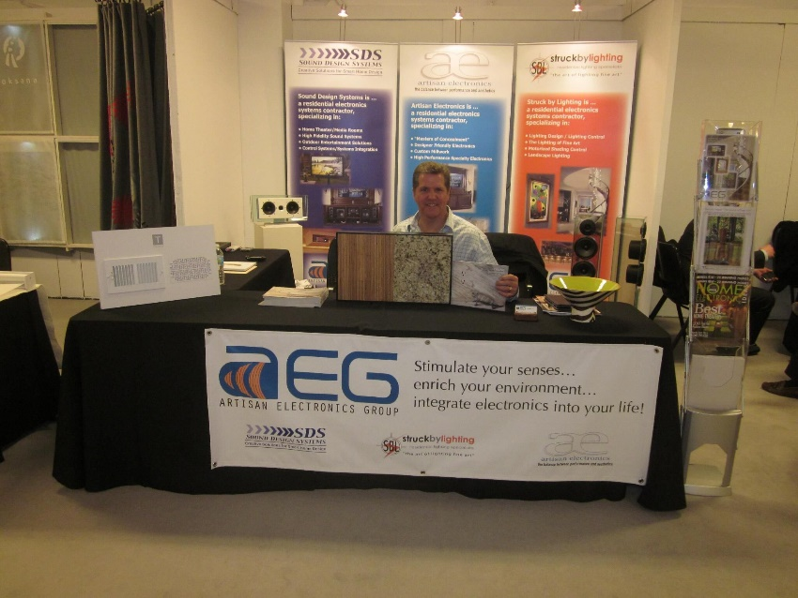

Neocon | June 2015
The next meaningful significant event in our March to the Mart was Neocon 2015.
Since diving headlong into our pursuit of the design community, of which the Merchandise Mart is its physical and spiritual epicenter, I had done more networking than at any other time in my professional career. When I jumped into the electronics business, I didn’t know a soul in the industry. Similarly, when we made the pivot toward the design community, I had virtually no contacts outside of the somewhat slow progress I had made through our membership in ASID.
One of the people that I pursued was Julia Chappell, who at the time was the Mart’s marketing director for the design center floors and showroom tenants. She became a great resource and friend, and was tremendously helpful in my getting a better understanding about how the Mart and the design community work.
As for Neocon, it is the largest trade show in North America for the contract furniture industry (which the rest of us call office furniture). Neocon, which celebrated its 50th anniversary this past June, has always been held in the Merchandise Mart and the two are often thought of as a common entity. Neocon brings 50,000 attendees to the Mart, on top of the 25,000 who pass through its doors on a daily basis. Think of it; 75,000 people in one building on a single day. I will tell you that for as large as the Mart undeniably is, it still feels very crowded with 75,000 people in it.
Every year during Neocon, the Mart has its own large display on the 7th floor exhibition space. In June of 2015, they used this space to promote their showroom tenants in the Casual Market (which the rest of us call outdoor furniture). The Casual Market represents a significant amount of business for the Mart, with several floors dedicated exclusively to high-end “outdoor furniture” brands. The Mart also hosts two of the largest annual industry trade shows for this category.
Through Julia Chappell and some of the rest of the Mart’s Neocon staff, they offered me the opportunity (at a price) to set up a sound system that could become a “display within a display” for one of their Casual Market showroom tenants. That ended up being a manufacturer by the name of Mama Green who builds a unique and eco-friendly outdoor furniture product, primarily for commercial customers, which is why they display at Neocon. The Apple campus in Cupertino uses Mama Green furniture in their outdoor spaces, just to name drop. We have it in our outdoor electronics display in our showroom.
Neocon is a three-day, Monday-Wednesday show held the second week in June. As such, our set-up time was scheduled for Sunday afternoon. This would be my second trip to the loading dock in the Mart. The sound system we were featuring was something I had developed a few years earlier, coincidentally also at the suggestion of Julia Chappell, who told me that with so many events taking place in the design community on a weekly basis, there were many venues that did not have their own sound systems. If we could create some sort of unique portable audiophile system that we could offer to the design community, that might be a way to get our brand in front of a new group of prospects. We did build such a system, centered around the beautiful glass speakers from Waterfall Audio of France, a longtime manufacturing partner and a good friend, as well.
We had been dragging this system around for a couple of years by this point in time, to all sorts of venues, where people were impressed with its capabilities and our presentation, but not so much as a whisper of a lead had been generated. I had been bugging Julia to help me find an opportunity to use the system at some event in the Mart and that became Neocon 2015.
My plan for Neocon was essentially to just baby sit the system for three straight days and see what would unfold. I had been struggling for months to get our new website completed in a form that would be a comprehensive overview of our ever-expanding offering, without being overwhelming. I thought that a change of venue from my home office might help stimulate the creative process. On Monday morning, I got all dressed up (something I had not done for many years) and went to the Mart.
Mid-morning that day, as I was sitting at a small table next to the Mama Green display, a man of about my age came up to me and asked me if by any chance that was my sound system in his display. With a warm smile, he introduced himself as Michael Galica. At that time, he was the North American ownership partner for Mama Green. He shared with me that he hadn’t really wanted to come to Neocon, as they had a local manager for their showroom on the 15th floor of the Mart who could handle inquiries at their booth. He told me that as he was getting closer to their booth, he could hear Latin Jazz music playing from what he knew was a high-quality sound system and was delighted to see that it was actually coming directly from their display. He had no idea that the Mart had worked with the local Mama Green showroom manager to put our system in their display, but Michael was very pleased that it was there.
As it turned out, the three days I spent at Neocon did not generate anything in the way of a usable lead, but that was not really the intent or expectation of the undertaking. It was to simply to be in the Mart for three straight days, and have some time to work on the website and marketing strategy for AEG. What it did yield was something much more valuable in both the short and long run, as Michael and I spent the entire three days in deep conversation together, and learned that we were uncannily simpatico, with an almost unbelievable amount of common ground. He was very interested in the story of what I was trying to build with my brand and is a very smart marketing person who proved to be a tremendous sounding board. He wanted to see every page that I had written for the website to date, and gave me both critical and useful feedback.
At that time, I had spent the past two years trying to sell the idea of getting placement for some of our more unique products into other showrooms in the Mart with the offer to pay a commission for any leads they might generate. Between the beautiful Waterfall Audio glass speakers and the fantastic TV concealment devices we use from Frame My TV, I was sure that I could find a taker somewhere on the 14th floor that would partner with us. I was so eager to plant any sort of flag in the Mart with our name on it that I was willing to give these products to any showroom that would partner with us, but I had no takers. In sharing this frustration with Michael, he was very succinct in telling me, “You need to have your own showroom.”

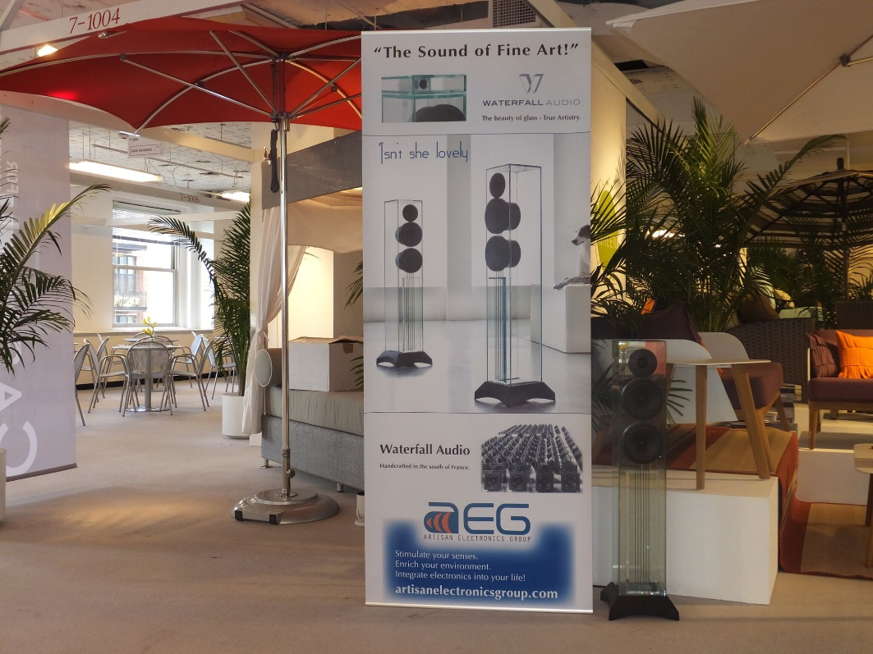

ASID Illinois Celebration of Design | September 17, 2015
Celebration of Design is the showcase event on the ASID Illinois calendar. It is the annual design competition awards gala, and it is a fancy, dress-up event which draws hundreds of attendees. Winning an award at Celebration of Design is a prestigious feather in any winner’s cap.
This event is also always very well sponsored because of its stature as such a showcase event. I thought this might perhaps be the right opportunity to dip our toe in the water and show some tangible financial support for ASID Illinois. We didn’t buy the absolute smallest sponsorship package available, but close. In addition to having our name and logo up on the big screen, I also had the opportunity to be a presenter for one of the awards, and I loved being up on stage introducing myself to the largest gathering of designers in Chicago that one can hit with one shot. It felt like a step forward in our pursuit of making our brand known to this audience. People seemed to be a lot more willing to talk with us after that. Funny thing, what financial support can do!
The specific date is meaningful for another reason. We finally launched the new Artisan Electronics Group website earlier that same day, which was gratifying, say nothing of being a huge relief. I had been so close to completing it for a couple of months, since my three-day pow-wow with Michael Galica, and I just felt like having a target date like our coming out event with the Celebration of Design sponsorship had to be the motivation to get it completed. I felt like it would be bad for business to be up on stage, introducing myself and AEG, and not have more than an “under construction” holding page for our website, just in case one of the attendees wanted to know more about this thing called Artisan Electronics Group.
I was very pleased with the way the website turned out, and still am. I wanted it to be something different than what everyone else in the industry was doing. That is the drum to which I dance.

The ASID Technology Forum | April 13, 2016
As I did in fact become more progressively involved with ASID Illinois, the chapter president asked me if I could develop a technology forum event for the chapter’s 2016 educational agenda. In addition to AEG’s involvement with ASID Illinois, I recruited another veteran of our industry and active chapter member, Joe Barrett of Barrett’s Technology Solutions, to work with me on this project. We co-chaired the creation and production of the event.
Within the CEDIA community, there are many outstanding manufacturers who understand the need to develop high-performance products that also have a tangible “designer element” to them. What we might have once called “design friendly” might be better described as “designer friendly.” AEG and Barrett both use several of the same manufacturers in this broad category, and our format was to put together a panel discussion representing five different manufacturers and give each of them a 10-minute time period to present their approach and strategy for creating the designer-friendly products in their line-up. Following each of these presentations, there would be a Q&A session between the audience and the panel. When putting on educational events of this sort, the chapter always tries to have it be approved for a CEU to draw the largest audience possible. I volunteered to write the CEU and undertake the process of getting it approved with IDCEC. Talk about be careful what you wish for. What a task that was!
One of the really exciting aspects of this project was having the opportunity to give our industry a strong voice in our ASID Chapter. We immersed ourselves in the project. Equally exciting was the venue where we were going to do the presentation, and that was the very shiny, very new showroom that Pella Doors and Windows had just opened in a very prime location on the posh first floor of the Merchandise Mart. With the intent of having it become a gathering place for industry events of many sorts, Pella and their architects did a magnificent job creating a showroom that could quickly be turned into a stunningly impressive presentation space, including a working kitchen and plenty of space for food and beverage service. Pella had barely opened their doors for business in the early winter of 2016. The first time our committee saw the space, I am sure that I gasped. It is an amazing showroom and seeing it the first time continued to fuel my fire about the continued escalation of the build out of luxury brand showrooms in the Mart, along with a significant level of capital improvement from the building’s owner. The Queen was being polished to a high shine.
Other than a couple of minor glitches with the P-A system in the Pella showroom, which was still working out the kinks of their overall substantial electronics system, I thought we put on an excellent presentation. During the Q&A, a question from a very influential member of the design community was put directly to Matt Miller, who runs the Chicago market for Lutron. John Cialone, director of design at Tom Stringer Design Partners, asked Matt, “Why isn’t there some sort of electronics experience center where the design community can come to see and touch technology and understand how all of these things work?”
As Matt somewhat stammered through an answer, I said to myself, “Why not, indeed.”
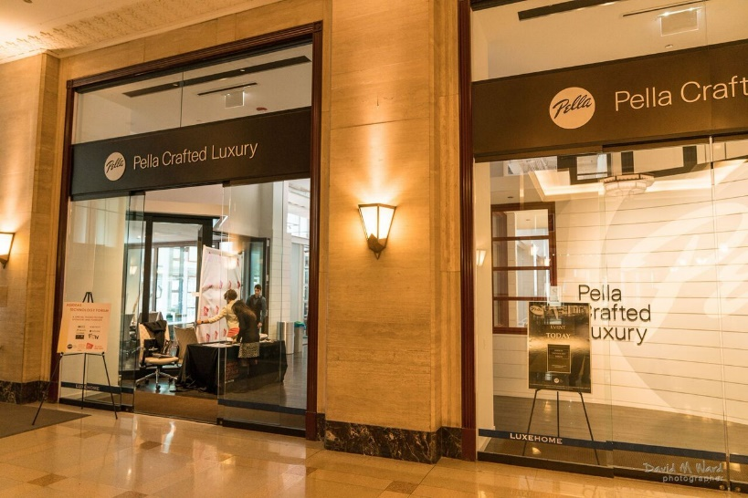
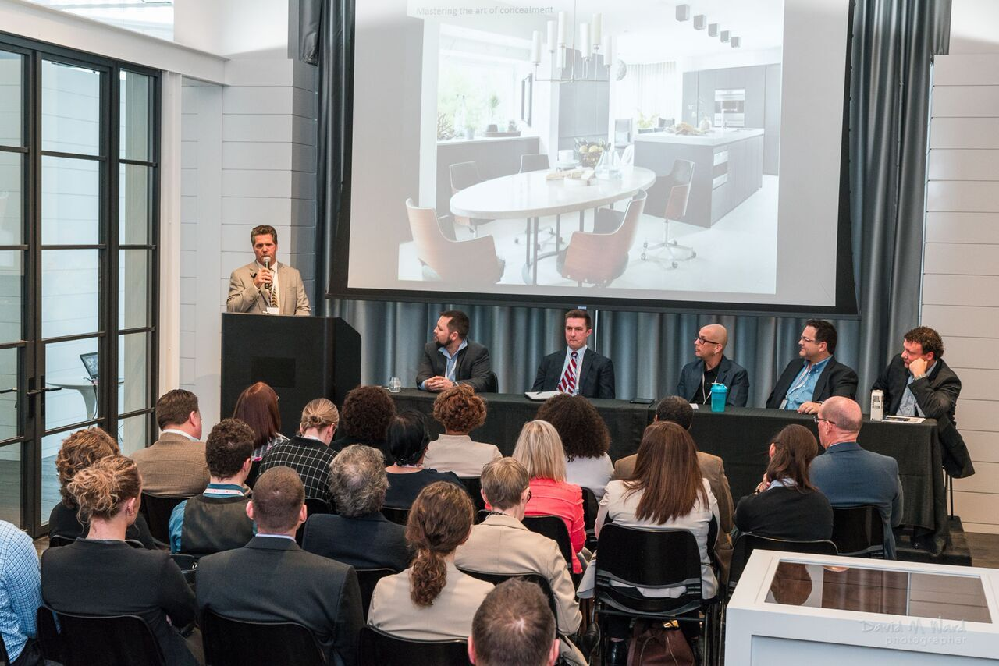

The Strategy Session | May 26, 2016
On the heels of the Technology Forum and John Cialone’s challenge to our collective industry, I had convinced myself that the creation of this “electronics experience center” might be something we could pull off ourselves and become the new trailblazer for our industry.
Over the course of our company history to date, I had developed something of a core group of individuals both within the industry, as well as outside the industry, that I looked to for advice and to help me in the constant process of brainstorming new ideas to try to build the better mousetrap. Among that group of confidants, none was more important to me than Joe Corona, who is someone that is well known to Draper. As I had said in the telling of the beginning years of our company, when I launched Sound Design Systems in 2003, I did not know a single person in the industry. It turned out to be my extremely good fortune that one of the very first people I was introduced to was Joe Corona, who at that time and up until the Fall of 2016, worked as a salesperson for the Chicago-based manufacturer Tandem Marketing.
Over the course of the 13 years that Joe and I had done business together, he had easily become one of my most trusted sounding boards for ideas and strategies, way above-and-beyond “just” selling me products. Joe and I had been talking about my growing obsession with the Mart for a couple of years, and he believed with the same fervor that I did that there was an enormous, untapped opportunity for whomever figured out the right way to pursue it. Without knowing what exactly that might look like, I knew for certain that for us, I did not want it to look like “every other AV showroom” in the industry. With no disrespect to those who make the investment to build and support showrooms, I believed that for us it was very important to do something more creative, more original, particularly if we were going to plant our flag in a location as prestigious as the Merchandise Mart.
The meeting in the sunroom of our home on the afternoon of May 26, 2016, was to brainstorm ideas specifically to come up with a strategy to take AEG to the Mart. The central part of the conversation was essentially to try to determine what element or category within our industry was underrepresented both in the greater Chicago marketplace, along with how whatever category that might be would fit in at the Merchandise Mart. Fortunately, we came to the conclusion within a few hours. It was the Eureka moment of a lifetime.
Within the entire Chicago market, the third largest city in America, there was no location where a person could go to see a wide selection of best-in-class theater seating. We certainly knew this to be true from our own theater building business over the years. On more than one occasion where we had built a very nice theater for a customer, we had tried to convince them to do high-quality seating, but had no real means to show or demonstrate anything from that category. Ultimately we not only did not make a seating sale, but saw the customer end up purchasing something less than a high-quality theater chair because that was what they could see and what they could sit in, which is how we believed a theater seat should be sold. So many people were buying product from the wide range of cheap seats because, thus far, nobody had offered a quality option to do otherwise. With excitement and enthusiasm, we all agreed that this was more than an underserved market opportunity and was, for all intents and purposes, unserved.
From there, the dots connected easily. If we were to describe our offering as best-in-class custom furniture, there is no better place on the planet to participate in that category than on the 14th floor of the Merchandise Mart. The nearly 250,000 square feet of the 14th floor is home to some of the very finest showrooms in the luxury furniture market. The anchor tenant of the floor is Holly Hunt, with a spectacular 31,000-square-foot showroom. When my friend Julia Chappell had first given me a tour of the 14th floor a few years earlier, she told me that within the design community they referred to the corridor that Holly Hunt is on as Rodeo Drive. The other showrooms on the floor are the absolute who’s-who of the top end of the residential furniture market. Our basic strategy and the key to our success was to create a state-of-the-art electronics experience center, cleverly disguised as a furniture showroom. We had to be on the 14th floor. It was time to get started.
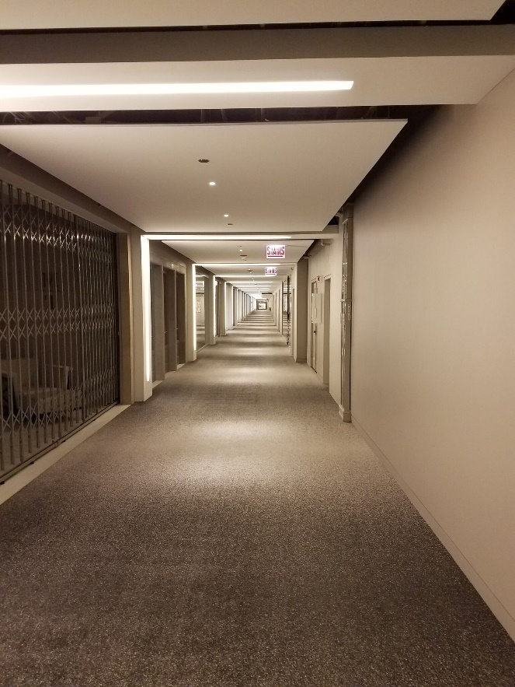

“Rodeo Drive.” Two full Chicago city blocks long

Finding Our Space | June 2016
At the conclusion of the brainstorming meeting, we agreed that the next step had to be to take the plunge and find out what space might be available on the 14th floor, and what would it cost. I had never explored commercial real estate before and had no idea what to expect. Those were a couple of significant unknowns that would certainly determine if this was something that would be within our reach or not.
I met with Julia Chappell within a few days of the strategy session to share the vision with her. Not surprisingly, she was thrilled and eager to help. She arranged for Joe Corona and I to meet with Kate Flaherty, the vice president of leasing, the following week. She warned me that Kate was a ball buster. Joe had also been busy putting out some discreet feelers to a handful of the manufacturers he represented and felt confident about the responses he had gotten from Fortress Seating and the regional management from Sony. At this point, we did not want to go too deep with our discussions with manufacturers because we still did not have any real measure of what the viability of this concept was going to be.
Joe and I met with Kate Flaherty on June 14, 2016, in the imposing conference room in the office of the building. We spent an hour in discussion about our strategy. Kate was certainly intrigued to say the least. She recognized that the addition of an electronics/technology showroom was something that would broaden the offering to the Mart’s showroom portfolio, and that the idea to disguise it as a furniture showroom was very clever. Although it was little more than a tease on our end, she very much liked the idea that we could bring in Sony as a potential partner. She said something to the along the lines of, “If these guys can bring in Sony, they must be for real.”
She took us up to the 14th floor and showed us two empty spaces—the only available spaces on that day. Not surprisingly, the 14th floor enjoys a nearly 100% occupancy rate. Both spaces looked too large for our needs and, needless to say, much, much too expensive for our financial capabilities. There was just no getting around that reality and I had to be realistic about it, with Kate, and myself. I thanked her for her time and consideration and asked her to please let me know if a smaller (less expensive) space became available on the 14th floor. I returned to business as usual.

The Sony Life Space UX Meeting | August 16, 2016
In the two months that had passed since the meeting with Kate Flaherty, I had truly put the Mart showroom concept on the back burner and returned to the regular ebb and flow of our business. I certainly never doubted the validity of the concept, but just felt like it was something bigger than we could undertake, in every respect.
Seemingly out of the blue, I got a call from Kate, inviting me to a meeting she was to have with Yoshiko Matsuda, who at the time was the head of a small boutique business within Sony known as Sony Life Space UX. This division had developed a handful of unique products that all had some level of very unique design-friendly element to them. Yoshiko wanted to visit the Merchandise Mart to explore a variety of possibilities to find a way to show their products. She was open to the concept of having a showroom of their own (unlikely, based on how small their product line-up was), creating a partnership with a showroom in the category (which was why Kate invited me to the conversation), or finding a showroom that would simply allow them to display their products. My previous attempts to do the latter afforded me the perspective to suggest that this was also unlikely to happen for them. The idea of forming a partnership seemed like the logical way to go.
The meeting was fantastic and suddenly I was back on full burner to the Mart. At the top of the product lineup for Life Space UX was an amazing device, in the form of their ground breaking 4K ultra-short-throw laser projector, a $50,000 device that could project a 150” 4K image directly on a wall from only inches away. It was one of the absolute coolest devices I had ever seen and believed that it could be a launching point/centerpiece for a partnership between AEG and Sony, or at least Sony Life Space UX.
Kate showed us an available space on the first floor in an area known as the Design Resource Center (DRC), which is a collective of what I would describe as being almost trade show like exhibits with multiple manufacturers displaying their products side-by-side. The DRC is managed by the Mart with a full-time concierge to assist customers with any of the displays. That alleviates the tenants from the need to man their space with dedicated personnel. This was very appealing to both Yoshiko and certainly for me, as AEG was not in a position to staff a showroom at that point. In parting, Yoshiko asked me to put together a proposal for a partnership, which was music to my ears!
I put together the proposal, which would essentially have made AEG and Sony equal partners in something I was now calling Sony at the MART as a working title, and quickly secured a web domain by that name.

Finding a Place in the Mart
The space we were considering in the DRC was approximately 600 square feet. I jumped into the design process head first with input and advice from Joe Corona. Unfortunately, it was not very long into the process when I started to have some serious concerns about our ability to create what I had visualized. My biggest concern was that we had no ability whatsoever to control the lighting in our space. The entire DRC, with its twelve to fifteen individual tenants, was on a single lighting switch-leg with hundreds of track lights and no dimming capability. One does not have to be an industry veteran to realize that the concept of having a 4K projector as the centerpiece of our showroom with no ability to manage lighting levels might not be a good engineering strategy. My other concern was regarding the capabilities of the DRC concierge being able to manage the responsibility to sell our products. With no disrespect intended, her training was more focused on showing customers faucets and doorknobs, and not so much state-of-the-art technology and electronics products. That said, I did have a leasing contract from Kate in front of us and was continuing to work toward a sign-off from Sony.
By this point, more and more people in Chicago had heard the rumblings about our intentions to open some sort of showroom in the Merchandise Mart. It was through this grapevine that I learned of a smaller space that had become available on the 14th floor. Kate Flaherty was on vacation at the time, but upon her return the following week, I called her and asked her if she could show me suite 1486. Upon opening the doors, I knew in an instant that this was where the future of our business and my dreams were going to play out. It was nothing special to look at and at that moment, but I could see it. Michael Galica’s prophetic words from Neocon 2016 rang loud and clear in my head.
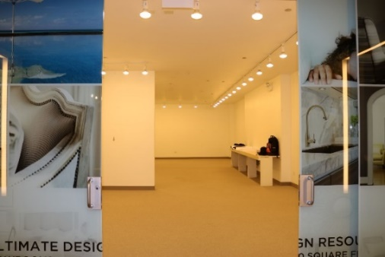
You need to have your own showroom!

Suite 1486
The right rime. The right place. The right space. | September 2016
I took a second look at 1486 the following week to reassure myself that this was going to be the right place for us. I have long been a fan of numerology and the fact that Suite 1486 was 1,105 square feet resonated with me, as that was the street address of my childhood home. I am always looking for signs of confirmation, no matter how small, and this one seemed just enough of a sign to suit my superstitions.
I asked Kate what the next steps would be. She told me that we could sign an intent to lease agreement, which essentially said that the Mart’s leasing department would take the space off the market for a period of 30 days, while we moved toward finalizing a more binding agreement. The document was simple and I was happy to sign it. At this stage, the only thing I was buying was time.
Another event that played to our favor was that the 2016 CEDIA Expo in Dallas was a little later in the calendar than its usual space right after Labor Day. I went back to 1486, took a bunch of pictures, and headed to Dallas to start securing partnerships. One thing that we knew for certain was that we would not be able to put together the showroom of our dreams without a tremendous amount of help and participation from our manufacturing partners. What we were also certain of was the idea that there were a great number of manufacturers who would love to have their products displayed in a showroom on the 14th floor of the Merchandise Mart. As I say, “it’s where they keep the money.”

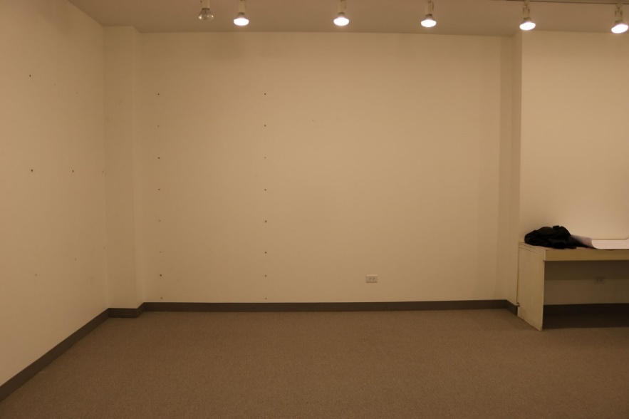
Screen Wall?

Who will help me bake the bread? | CEDIA 2016
My mother taught first grade for as many years as I can remember and one of her favorite parables was the story of the little red hen. It was a story that she shared with her students every year and also with my brothers and me at any time she thought it was fitting. For those who might not know the tale, it is a simple moralistic story about the importance of sharing the work load in order to reap the benefits of the final reward. If you don’t do the hard stuff, you don’t get the good stuff.
Most important on our list was to secure a seating partner and we had been in passing conversation with Fortress for a few months. Now that we had at least put a placeholder on a specific space, it was time to get serious. Suffice it to say that our meetings with Fortress at CEDIA went very well, and by the time I headed back to Chicago, we had a handshake agreement for both product and a shared participation in the overhead. After all, the entire showroom was going to be built around theater seating and we expected (and needed) a substantial commitment from our seating partner.
Next on the list was Sony and I was finding them to be a bit more elusive than what I had hoped would be the case. The short version is that there are a great many layers of decision making within a giant global organization like Sony, with lots of opinions through the various layers.
I also made the rounds with many of the manufacturers that I had done business with over the years, as these were certainly the logical people to join us in this venture. We met with Elan Home Systems, Triad, Draper, and Sonance, to name a few. Everyone seemed to agree that focusing a business model more specifically on the designer market was an area that had long been underserved in our industry.
Elan in particular was very interested in the idea, as they had actually been in the process of looking for creative ideas to bring their product into a design center. Crestron, Savant, and Control4 already had varying forms of small showrooms in a handful of design centers around the country, as stand-alone showrooms for those products. Elan was not in a position to create their own branded showroom, but they were extremely interested in finding a way to partner with one of their dealers. We had been a loyal Elan customer since our first days in business. They wanted to come visit the space right away.
All told, I left CEDIA in a very positive and confident frame of mind, believing that this crazy dream really could happen.

Elan, Fortress, Sony | October 2016
Bret Jacob from Elan came to Chicago on October 10, 2016, to look at the space, along with Joe Corona and me. For as much as it was still a very non-descriptive space, Bret loved it and felt the enormous energy in the Merchandise Mart and on the 14th floor. At that point, we were still a long way from signing a lease, in my opinion, but Bret said that he believed he could sell the idea up the decision-making ladder at Core Brands for both product and rent participation. Hooray!
The next day I headed to L.A. to visit my daughter and her fiancée at their new home, but it was to be a working trip, as well. I had come to learn that there was an integrator in L.A. who had run their business for many years from a showroom in the Pacific Design Center, the Merchandise Mart of Los Angeles, and I wanted to see their space and talk with them about their experiences doing business in a design center. Additionally, I had a trip planned to the Fortress Seating factory to get a first-hand look at their business and try to get a more formalized level of commitment from them. Lastly, I had hoped that I would be getting an answer from Sony at any moment.
My trip to the Pacific Design Center was a little underwhelming. For as much as people in L.A. put it on the same level as the Merchandise Mart, in my opinion it is not. The Mart is quite simply much larger and much busier. I thought the PDC was a bit of a ghost town. When I met with the owner of the AV showroom there, I asked him if it was always like that and he said that it was. That said, they had managed to be in business there for 20 years.
My meeting with Fortress the next day went great. It’s a bit of a hike form my daughter’s place in Culver City out to the Fortress factory in La Verne, near San Bernadino, and I planned to make an all-day trip. After getting the stem-to-stern tour of the factory, I spent a couple of hours with Don Wolper, the longtime company owner, discussing my business plan and strategy, and he thought is all sounded fantastic. We went out for a lovely celebratory late lunch and he asked me to follow up with a specific proposal. I was on cloud nine!
Within minutes of arriving back at my daughter’s, my balloon instantly burst when I got word from Sony that they did not want to participate in this venture. Bureaucracy being what it is, they simply said “we’ve never done something like this before.” Not with product and certainly not with rent participation. The higher-level decision makers had never even seen the Merchandise Mart and didn’t know what it was, beyond name. Plus, they certainly had no idea who I was.
We tried to look on the bright side, feeling that we had secured our seating partner, which we ultimately believed was a more critical element, at that time.

She loves me. She loves me not. | November 7, 2016
Being the glutton for punishment that I am, I had not given up completely on Sony, and had been pursuing a different tangent with Yoshiko, as I knew that she was still very enamored with the Merchandise Mart. All it takes is one visit. From my side, I really wanted the 4K ultra-short-throw laser projector and was willing to take on their other lesser products in the Life Space UX collective if I could get my hands on the fancy projector. I persuaded Yoshiko to make a trip to Chicago from New York to see Suite 1486 and work toward a path that would satisfy both of our needs, and she made that visit on November 7, 2016.
Yoshiko really liked the space and agreed that it would be much better suited to demonstrating a projector than the space we had looked at together in the Design Resource Center. Now that it was time to get serious, she did make two very specific requirements that would have to be satisfied in order for us to get the ultra-short-throw projector. The first of those was that we had to be able to demonstrate the projector on a standard wall and not use a traditional theater screen of any sort. Sony’s strategy for this product was to show it as a means of doing large scale 4K projection, but in a more traditional living space environment. In addition to demonstrating the projector on a wall, they also demanded that it not be in a theater vignette, but in more of a living room type of exhibit.
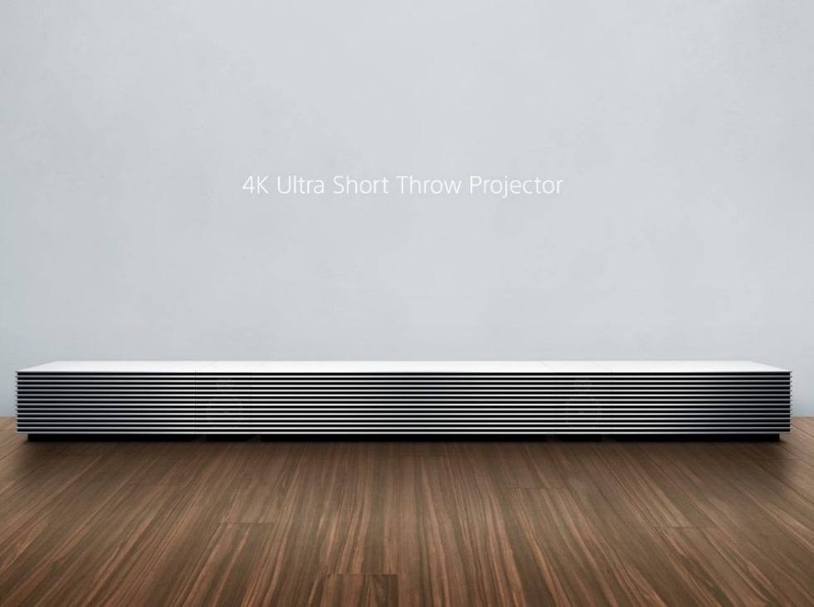

Yoshiko and I went to lunch to celebrate what seemed like a genuine turning point in our desire to work together toward a common goal in the Merchandise Mart. I truly believed that this unique projector was something that would have a tremendous appeal to the design community and would show well and sell well in a showroom in the Mart. Because we were no longer asking for any sort of rent participation, it was within Yoshiko’s decision-making power to work with us on product. It felt like a real building block had been added to our foundation. On the ride home, I called Kate Flaherty to let her know that my meeting with Yoshiko had gone very well and that things seemed to be on track with our Sony partnership. Kate had played a crucial role in bringing Sony Lifespace UX and AEG together and I felt it was important to keep her in the loop. I continued to have the sense that it was very important to Kate to have Sony be a part of this.
Although it had not become an issue yet, our 30-day grace period under our intent to lease agreement had expired on October 22. Kate had put an official lease agreement on the table, but had not pressed me on it, thus far. A four-page, single-spaced, size-eight font agreement. Fine print, indeed.
In a cruel twist of fate, it was later the same day after returning to our suburban office, that I heard from Don Wolper at Fortress, saying my plan was just a little “too rich for their blood.” For as much as they thought the strategy was right on, they were not prepared to dive in as head long as I had asked for their participation. It was a definitive “No, thank you.”
It just seemed to me to be all but unfathomable that I could have Fortress in and Sony out, on the same day, and less than 30 days later have Fortress out and Sony in on the exact same day. This roller coaster of a ride to try to pull all of this together was really starting to wear on me. After my conversation with Don Wolper, I put my head down on my desk and closed my eyes.
As Georgeann and I discussed the events of the day over dinner that evening, I told her that I didn’t think that I was going to be able to pull it off and was seriously considering folding my hand. I had been focusing a huge amount of time and energy on the project over the last 90 days, and if it wasn’t going to pan out, I needed to focus on getting back to our core business. Rather than throw in the towel at that moment, I agreed to give it 24 hours to settle out and regroup and see what the light of the next day would bring.

Cinema Tech
I think that a poll of most theater builders in our industry would agree that the two top manufacturers in the category are Fortress and Cinema Tech. Although at this point in time we had not done business with Cinema Tech, they had been pursuing our business for several years, so we did have some contacts within that company. At CEDIA a few months earlier, I did meet with Cinema Tech and gave them a little bit of a tease about my idea for a showroom in the Merchandise Mart built around theater seating. At that time, I did not tell them that I had secured a space (or at least squatted on one) in the Mart, as I believed that it was going to be Fortress who was going to be our seating partner and I did not want to share too much information at that point in time.
After scraping myself up off the floor following the Fortress rejection, I waited a day and decided to make a call to Cinema Tech and pitch the idea to them. I first floated the idea to my sales rep at Cinema Tech and he loved the idea, but was not in a position to be a decision maker. He asked me if I could put together a formal proposal that he in turn could share with Michael Murphy, the owner. Given that I had put together a very detailed proposal for Fortress after my visit there in October, it didn’t take much to dust if off and change the name of the seating participant.
Within a couple of days of sending the proposal, I heard from Michael Murphy saying that he was very interested in our proposal and would like to have a more detailed discussion about our strategy and business plan. That conversation took place a few days later and went very well. It turned out that Cinema Tech had been exploring the idea of opening their own showrooms in a few of the more prominent design centers in the county, most notably the PDC in L.A. and the Design Center of the Americas (DCOTA) in Florida. They were certainly familiar with the Merchandise Mart, but at the time did not have any plans to do something there, so it was very appealing to them for AEG to have a very specific plan for selling theater seating from a showroom in the Mart.
That conversation took place on November 17, 2016, and we agreed that the next step in the process would be for Michael to come to Chicago sometime in early December to see the space and see if we could put together an agreement. Talk about a heavy sigh of relief! It seemed like the roller coaster ride was headed back in a positive direction.
It must be said that we were very close to being 30 days past our 30-day deadline on our intent to lease agreement and Kate Flaherty was now very much starting to push me to sign a lease or allow her to put the space back on the market. Fortunately, the Thanksgiving holiday was the next week, which bought me just a little more time to work on this gigantic jigsaw puzzle.

The design process begins.
From my very first visit to suite 1486 on September 12, 2016, I had made many return visits to look at this empty box and dream about what it might become. Kate Flaherty’s assistant had been very accommodating about letting me look at the space and I was probably there at least once a week over the course of that 60-day period from when the intent to lease agreement had been signed. Of course, the Mart wanted to see this come to fruition, so it only made sense to give me access to the space, within reason.
With the planned meeting with Michael Murphy being a few weeks out, I decided that the time had truly arrived to make some decisions about what we were going to do with the space, now fully believing that we were back on track toward making this giant dream a reality.
In early 2016, I had been fortunate to find a very talented individual to help us do renderings and all other sorts of drawings, be they CAD, 3-D or any other sort imaginable. Suzann Nordstrom had been teaching technical drawing skills at a variety of design schools in the Chicago area for 20 years and had decided that she was interested in doing some freelance work in addition to her teaching responsibilities. I found her on LinkedIn and reached out to her for help on a theater design project we were working on and was blown away by her skills, in addition to finding her to be a delight to work with. I was tremendously impressed at how well she could take my verbal and written directions and recreate exactly what I had visualized.
On the Monday before Thanksgiving of 2016, I asked Suzann if she would come to the Mart to meet with me in suite 1486 and talk about space planning and some design ideas that had been percolating in my head for a couple of months now. She took copious measurements, such that we would have an accurate and to-scale sense of what we were working with. To her credit, for which she is much too modest, within a couple of hours we had come up with a very clear sense of how we could best use every inch of this 1,105-square-foot space to create something really magical, including a 12-seat theater as the centerpiece for the showroom. Before the holiday weekend was over, Suzann had sent me some preliminary drawings for the space and I was so excited! Her drawings were once again magnificent and exactly what I had visualized for the space, if not more so. I could not wait for Michael Murphy’s visit to see the space and the fantastic drawings that Suzann had created.

Closing the Deal
Michael Murphy made his visit to Chicago on December 14, 2016, on what turned out to be one of the most frightfully cold days of the Chicago winter, particularly for that early in the season. Although a native Bostonian, Michael had long since relocated to Dallas and the weather that day was a real shock to him. He wanted to get in and out of Chicago as quickly as he possibly could, saying, “Why would anyone want to live in a climate like this?”
The meeting went very well. Given his relatively quick turnaround, we were all business. We went up to 1486 to look at the space and review the drawings that we had prepared thus far. Michael liked the space and liked the drawings, but made a couple of very significant suggestions on a few tweaks that we might make to the current design.
The Sony 4K ultra-short-throw projector was prominently featured in the drawings for our theater and I shared with him the demands Sony was putting on us in order to secure their partnership, most notably the need to demonstrate the projector on a wall rather than a screen, and also that they did not want the device to be in a true theater-like vignette. His suggestion to us was that he thought we would be better served to build our showroom around a concept (luxury home theater) rather than around a specific product (Sony ultra-short-throw projector). He also said that, particularly in a venue like the Merchandise Mart, we should endeavor to build the very finest theater that the space and our budget would allow, saying, “The higher the quality of theater you can show, the higher the quality of theater you can sell.” I found it hard to disagree with what sounded like very good logic and took those recommendations to heart.
Within a day or two of that meeting, Cinema Tech agreed to become our partner in the venture that would come to be known as AEG at the Mart. Given that it was now December 19 and we were almost two full months past our intent to lease agreement grace period, Kate Flaherty was by now stalking me very aggressively to sign a lease or let the space go back on the market.
On December 28, 2016, I signed a three-year lease for suite 1486 and wrote a very large check to the Merchandise Mart to secure the space. We set a possession date of March 1, 2017, with a projected move-in date of June 1. So much work had been done in the past six months, but that would not even begin to compare with what lay ahead of us for the coming six months. We took a very brief pause for Christmas, to be with our families and to be thankful, then dove headlong into an entirely new reality.

Bringing 1486 to Life
The opportunity and challenge in front of us, to build the most sophisticated, beautiful, creative, and original AV showroom in the country, if not the world, was a heady task to say the least. (Say nothing of lofty!) As I told family and friends, this was truly going to be our moonshot. All the marbles, no turning back from here. This venture will either make us rich and famous, or it would very likely sink us. Because of the enormity of taking on the Merchandise Mart), I didn’t ever believe that we could be somewhat successful at this because that just wouldn’t be enough to make a go of it.
The process became all about compartmentalizing everything simply to protect myself from becoming overwhelmed. My belief was that when March 1, 2017, arrived and we got the keys to the kingdom, it was vital that we know exactly what it was we were going to build the moment we walked in the door. No unlocking the doors and saying, “Now what?”
In the months that I was squatting on the intent to lease agreement, I walked the corridors of the 14th floor endlessly to see how the rest of the showrooms presented their wares and their brands. I came to realize that for the most part, more than 90 percent of the showrooms fill their ceilings with track lighting, full-bright, and then put as many different furniture vignettes in them as their space would allow, be that 5,000 square feet or 32,000. After all, the furniture is the star of the show. At the end of the day, these were still just furniture stores. They had fancy floors and nice wall coverings and so forth, but they were still a retail environment. A very, very exclusive retail environment.
Because the centerpiece of our showroom was to be a dedicated 4k full Dolby Atmos theater, we wanted to create a space that would have a true residential feel to it, to the largest scale that we could believably recreate. We knew that we would need the space to be a bit on the dark side, lighting-wise, to be able to demonstrate our theater impressively. We also liked the idea of creating something of a moody, mysterious space by having a dimly lit space adjacent to all the spaces around us which were illuminated brightly enough to be seen from the moon. Rather than dimly lit, I would rather describe our space as “brilliantly dimmed,” as we went to great lengths and expense to create a ceiling and lighting plan that would be the equal of a truly fine residence. Not surprisingly, it was in the Holly Hunt showroom, quite possibly the finest furniture showroom in the country (or greater) that I saw a multi-head recessed fixture that I knew was exactly what I was looking for. People warned me that it was going to be expensive. At that point in the process, I was still brushing off comments like that, thinking “How expensive can it really be?” They say that ignorance is bliss.
Another important part of the process was that we were committed to using very high-quality materials for all our finishes in the showroom, such that it would believably replicate a small cross-section of a multi-million-dollar home. Certainly, by this point, I had become an ASID true believer and one of the tenants of that group of individuals, of which I am proud to be one, is to “live the brand.” We firmly believed that we would benefit greatly from hiring a designer to help us with the look-and-feel of our showroom. Tt could not have been truer. Through my volunteer work with ASID, I had come to know Jase Frederick, a designer who at the time was the chapter president. In various committee meetings, I had come to like the way she communicated and had heard her say quite emphatically that she was ready to be done serving at the beck-and-call of absurdly demanding wealthy homeowners and asked her if she would be interested in working with us on our showroom design. In a heartbeat, she said yes. We were on the path to doing something original and there was going to be no stopping us.
As another aspect of “living the brand,” I reached out to as many ASID industry partners for help with the project as I could, many of whom I had never met, but considered us all to be a Band of Brothers. It really gave Georgeann and me a wonderful sneak preview of what it might be like to design and build a luxury home and we loved it. This part of the process was so much fun! We laid out Suzann Nordstrom’s drawings on our dining room table and put carpet samples, wallpaper samples, flooring samples, etc., in all the right vignettes. We looked at it every single day and transported ourselves to this magical place we believed we could create. I said, “If we can build it even close to what these drawings show, it will be a major accomplishment.”
The time had come for the unveiling, and what you’ll see on the following page is what we wanted to build. Our plans were ambitious, but the entire premise of the March to the Mart was ambitious. From this point forward, all of us who were a part of the decision-making process were all committed to creating this space in a way that would befit the significance of being the first in our category, ever, to plant a flag in the Merchandise Mart for the AV and Integration industry. We felt that we owed it to ourselves and our industry to create a magnificent representation. We had no idea what it was going to cost, or how hard it was going to be to pull it off, but we were committed to a specific vision and were not to be stopped. When we looked at these drawings our feeling was that if we could actually build something that was even close to this, we would have achieved a major milestone for the Consumer Electronics industry in Chicago.
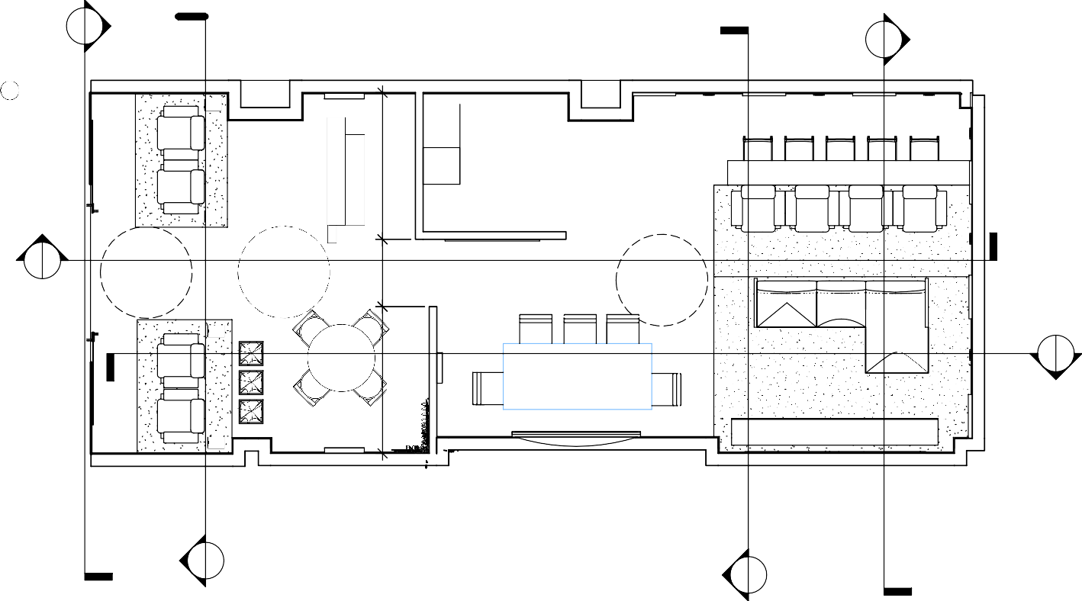

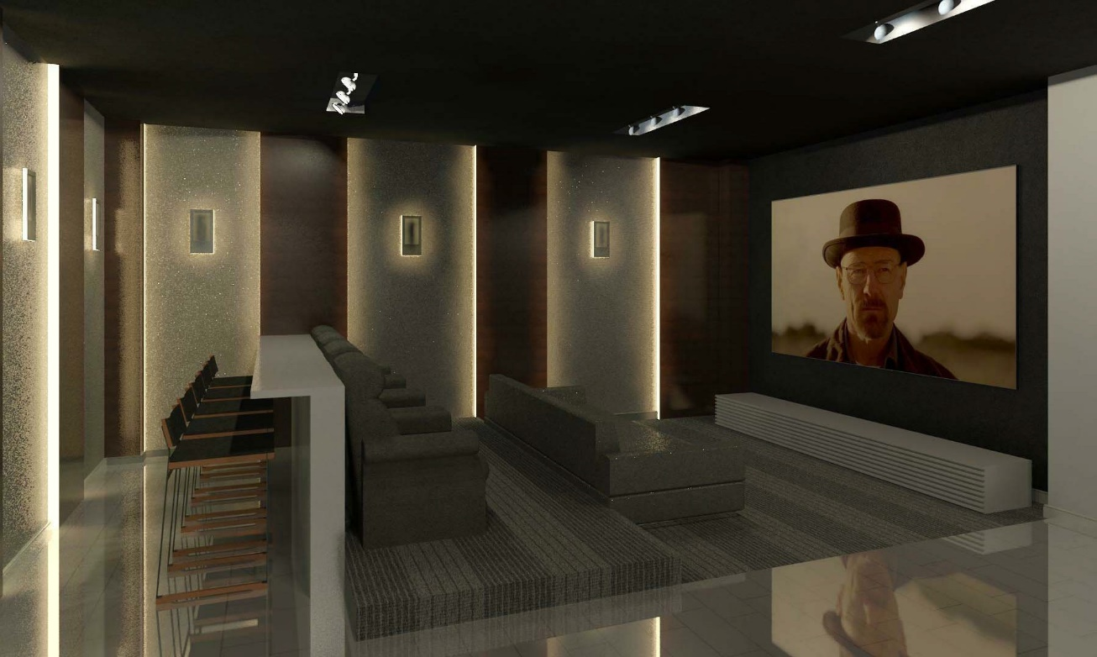
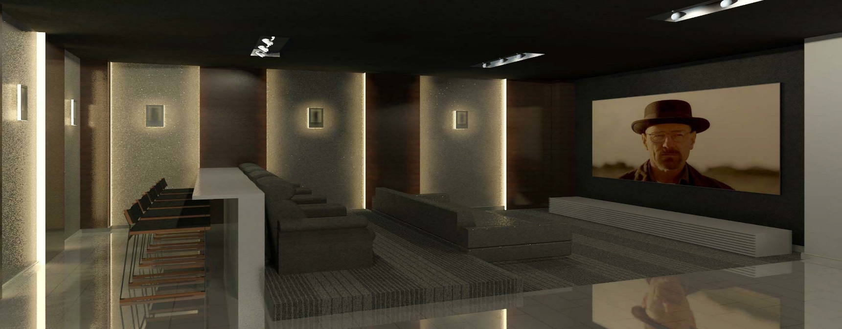

The Electronics System: Where Performance Meets Aesthetics
Visitors to our showroom ask us daily, “Are you in the furniture business or the electronics business?” Our answer is that we are in the electronics business and we happen to sell a category of furniture whose application is exclusive to our category: luxury home theater.
For all the beautiful and imaginative elements that we had planned for our showroom, nothing was more important to me than having the opportunity to build the single most fabulous electronics system I had ever created. I was certain that I was up to that task. Put into perspective, it’s all but unheard of for any customer to go full buy-in for the highest caliber of system that I design and propose. The next time will be the first time. That said, the design of the system for AEG at the Mart presented an opportunity and challenge to show just how much engineering and system design chops our brand could bring to this 1,105-square-foot space.
“Where Performance Meets Aesthetics” has been AEG’s formal brand positioning statement for some time now, and we live up to it to the best of any project’s ability to let us do so. We are first and foremost focused on the performance of the systems we design. If the focus of a project is high-quality distributed audio, it will be the best sound system you’ve ever heard of. If the focus is a dedicated residential theater, it will be a cinematic experience, such as most people don’t know can even be created in a home setting.
For AEG at the Mart, our 12-seat theater would be the centerpiece of the showroom. It would need to be beautiful to look at with the lights on and mind-boggling in performance with the lights off. At this stage of the system design process, we still believed that we were going to have the Sony ultra-short throw projector as a cornerstone of the theater, which required a tremendous amount of design work for the front wall. It had been our intent all along to use the Amina Mobius 7 invisible speaker for every channel in the system other than the subwoofers. It is hard to imagine that there could be any device in the AV world that would be more designer-friendly than a speaker that is truly invisible. These speakers also provided a perfect solution for the need to show an image on a standard wall, in support of the ultra-short-throw projector, without a compromise in sound quality. We knew that the ultra-short-throw projector was going to be a specialty item and recognized the need to show a more traditional front projection configuration. We specified a ceiling mount Sony 4K projector and a Draper 120” motorized acoustically-transparent screen, believing this would be our primary form of system demonstration.

The Build Out
This is by far the most difficult part of the story to tell succinctly because it represents the most challenging, thrilling, and frustrating 10 weeks of my adult life. I’ve been dreading its telling since first asked to write this paper more than a year ago. It was a task that took every ounce of energy, creativity and money that I could summon, and every single day of the build-out process could be a chapter of its own. Perhaps that will be the next story, all its own. There’s plenty of material with which to work.
People had advised and warned me that I needed to prepare myself for what a build out in the Merchandise Mart was going to entail. Naturally I expected that it was going to be expensive. Our original budget strategy was to double what we thought it would take to build a room (which is ultimately what this was going to be) of this sort in DuPage County, which is where we had been doing business since 2003. I will cut to the chase and tell the reader that it ended up being closer to quadruple that number. That’s shocking for a couple of key reasons. Those being that it illustrates the pricing-absurdity of doing construction in a true bastion of City of Chicago Union Labor and, much more frighteningly, we simply did not have the personal financial resources to make that happen when we were at a point where we had no option other than to move forward as quickly as possible. If we were going to start making money in the Mart, we needed to be open for business in the Mart.
I had mentioned earlier in this telling that it was my observation that the clear majority of showrooms on the 14th floor and the design floors in general, were fairly simple in design concept. Install as much track lighting as could be crammed on the ceiling, put in a new floor and a fresh coat of paint, then bring in the furniture! Because there are so many showrooms in this giant building, the Mart sets aside space in the bowels of the building for several very large contracting firms to have full-time shops with full-time crews. It is these contractors who do all the showroom build outs and updates in the building. There is no free-market bidding process within these walls. If you want to lease showroom space in this building, the Mart is going to assign the tenant the contractors that they believe will best suit that tenant’s needs. The contractor tells the tenant what it will cost and the process moves forward. Track lighting, new floors, new walls, and it’s done. If they’ve done it once, they’ve done it a thousand times. The demand for showroom build outs and updates keeps them busy 52 weeks a year. There was almost nothing I could do to change that and silly for me to think otherwise. In that regard, I’d like to think of myself as a fairly quick learner.
With no offense intended, I knew that what we wanted to build was simply going to be much more complex, infrastructure-wise, then what the “standard showroom” required. Particularly a puny space like suite 1486! To say that we were an afterthought on the overall project agenda in the building is just a statement of fact. It was only coincidence and bad timing on our part to have scheduled our planned opening so immediately close to Neocon. There are many showrooms on the 3rd, 10th, and 11th floors that completely gut their showrooms prior to Neocon every single year. This is just built-in work for the building’s team of independent contractors. What did we know? We were just looking one day at a time from the starting line to the finish line. The team believed they could do our build out in six weeks and worked their way back from June 1 to there. I, on the other hand, did not believe for one moment that a room this complex, with this amount of overhaul, could be completed start-to-finish in six weeks. I was very vocal in expressing that opinion. As you might imagine, that was wasted breath.
The one big concession that I was able to extract with the general contractor (GC) was that I would serve as the project manager for the build-out, while agreeing to use all the GC’s subcontractors and manage them through them. I asked to have an end-of-day discussion with the GC’s PM at the end of each work day. I intended to be on them as much as I could possibly get away with, not just because I was unhappy with what I had seen of the process thus far, but truly because I knew that this is what would be required to get our showroom built to the absolute most precise interpretation of my vision as imaginably possible. I’m trying my best to not have this be a story of an adversarial nature because it is not. We love being in the Merchandise Mart and want to be there for a duration of our choosing. It was all part of a learning experience and we have learned so much.
The union trades in Chicago work a 6 a.m. to 2 p.m. shift. For me personally, that meant if I was going to be serious about being the project manager, I was going to need to set the alarm very early. For eight weeks, I was out-of-bed at 4:30 every morning, hoping to be on the road to the Mart as close to 6 a.m. as I could get out the door. I did this every single day of the buildout save one, when my son and I attended Fast Friday for Indy 500 qualifying, as we do every year. Fortunately, on that day in mid-May, the painters were working in the showroom and we were very satisfied with the painting subcontractor, so one day of hooky seemed reasonable.
The curve ball that I threw to all the contractors was that we did not have any engineering or architectural plans drawn for this project. We just didn’t have the money. I believed that we could work with Suzann Nordstrom’s beautifully scaled renderings and build the room from there. This would not be the first time that I had drawn out a room, on the room itself.
This is the part of the telling where I introduce Steve Rainey, who has been a long-time protégée, partner, and friend, and without whom I would never have been able to complete this project. The very day that we got the keys to 1486, Steve and I began the process of literally drawing out the room. We used painters’ tape, lasers, sharpies, and good old-fashioned #2 pencils to literally take Suzann’s drawings and extrapolate them to-scale on the walls, floors, and ceilings of this space. Forgive the immodesty, but we got it exactly right to the tightest tolerances.
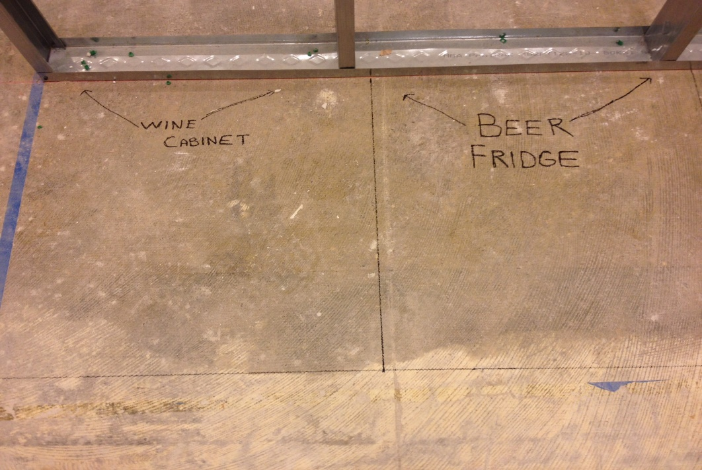 Priorities
If a person is looking for an effective weight-loss-program, personally managing the build out of one’s own showroom in the Merchandise Mart is almost a certain guarantee of positive results. For me, it was 20 lbs. in 10 weeks. I’ve put some of that back on, but am still the most-trim that I have been in many years. This endeavor keeps me running.
My belief that it was going to be vital for me to be on-site every single day during the build out was well founded. In the spirit of fairness, I was asking these contractors and subcontractors to build something that was unfamiliar to them. I had stated from the outset that I was not there to tell anyone how to do their job. My objective was to be there to answer questions, provide guidance, and when something wasn’t going to work the way that I had hoped it would, to convene a gathering of opinions and make a decision for how to respond. We were behind on the schedule and everybody knew that we were behind. I just did everything I could to either stay on schedule or perhaps even claw back a little time. Without going into specific detail, we knew what time of day the union crews cleared out of the building, and Steve and I attacked the space into the middle of the night on many an occasion. We consider ourselves to be the best-in-the-business when it comes to our overall design-build skills, and there was simply no scenario by which anyone was going to put together our electronics system other than us. This was just another example of what makes us so incredibly atypical of all the other showroom tenants in the building. Most are owned by large out-of-market brands with dedicated budgets for build out, remodeling, and updating. They punch-in and punch-out. This was to be our life’s work.
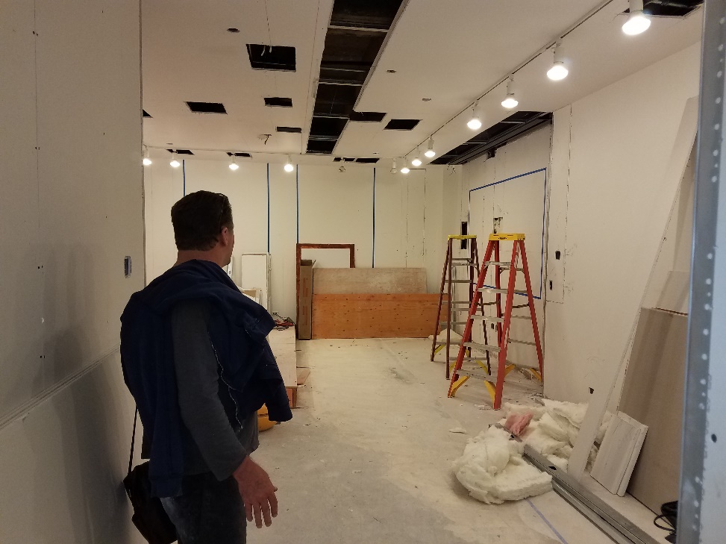
Open for Business!
For as much as being a part of Neocon 2017 had never been a part of any element of our business strategy, we were so close to hitting that timetable that everybody, including the CEO of the Mart said, “We have to get you open in time for Neocon.” Does it sound bitter for me to say that in my opinion, I think we should have been open for business weeks before Neocon?
With that whirlwind of an objective firmly seated as our target, I will say that the painters completed their work around noon on the Friday before the coming Monday start of Neocon, and that is when Steve Rainey and I began assembling the gigantic electronics system known to her friends as Bertha.
So ambitious were our goals that we had promised to host a cocktail party for ASID Illinois on the Tuesday night of Neocon. Steve and I worked without sleep for three straight days and, with frayed nerves, did not leave 1486 until the wee hours of Tuesday, June 13, planning to return later that day to fire up the system and pronounce to the world that AEG was open for business in the Merchandise Mart. Although the showroom’s electronics system was far from complete, we threw open the curtain and wowed our guests.
Our Official Grand Opening
Following the whirlwind of Neocon, we locked the doors and disassembled the system with the objective of taking the required amount of time to put it together properly the second time. We knew that this would be a measure of weeks and not days. In my mind, the week following the July 4 holiday is when we opened the doors for regular business and we have been open every day since.
On August 10, 2017, we held our official grand opening and it was a magical day. As a part of the marketing agreement between the Mart and its showroom partners, everyone gets an official grand opening and a part of that is having our message displayed on all the many digital displays throughout the building. For me, the feeling I had when seeing these images with guests coming from all over the country to be with us was nothing short of overwhelming. Excited as I was, even then I knew that we still didn’t know what we didn’t know.
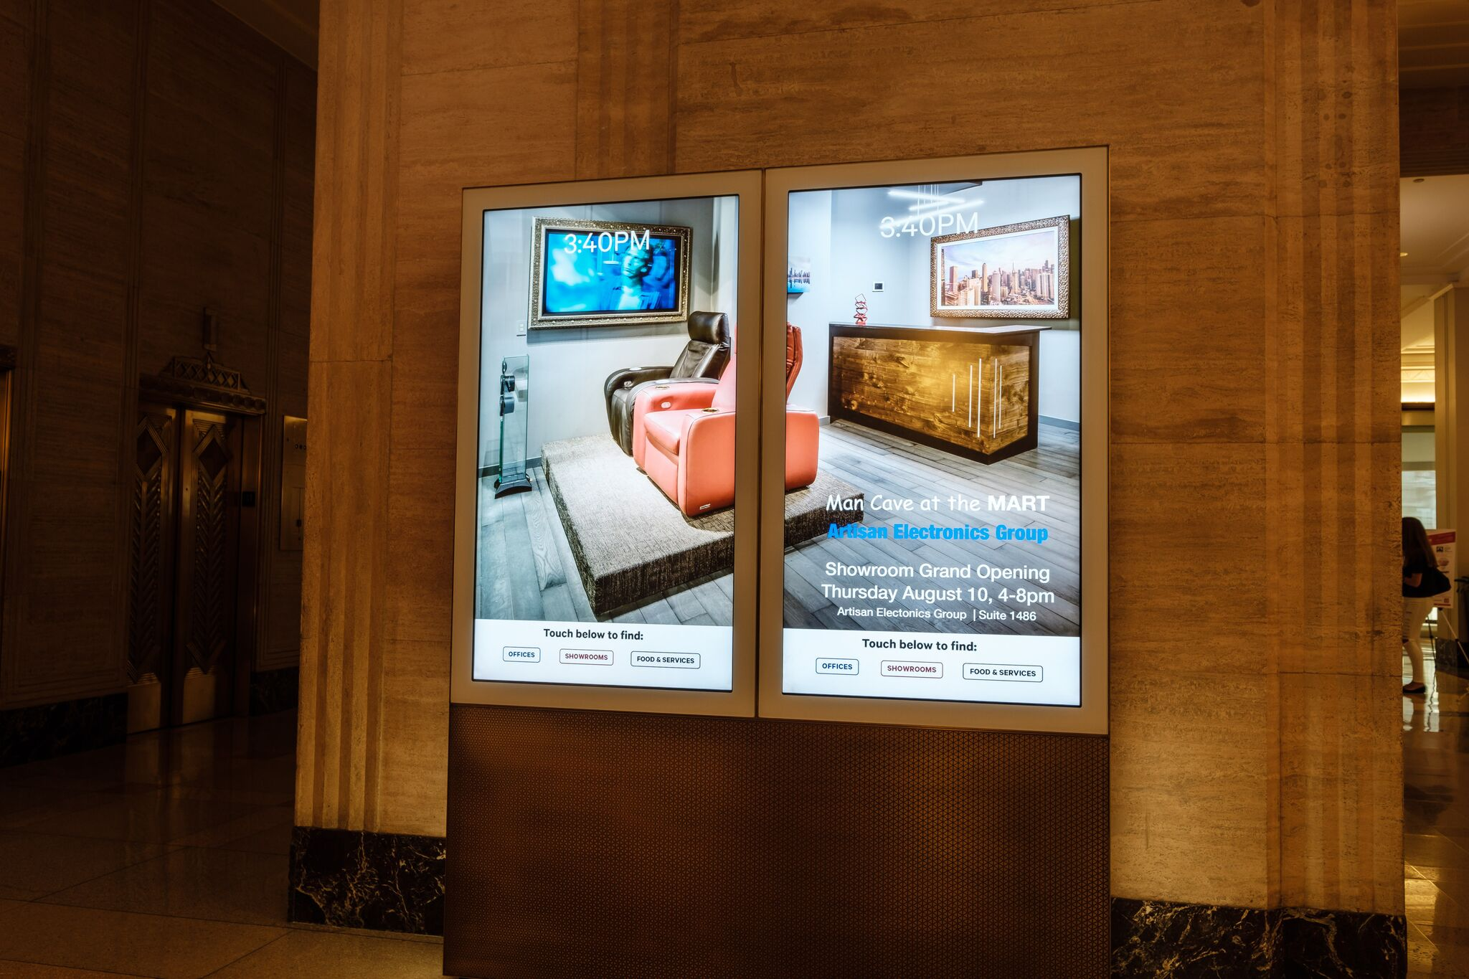
Short of a family wedding, our grand opening was as meaningful and joyous an event in our lives as any could be, and we were so grateful to receive the show of support that we did for this momentous occasion. Those who are close to us know and understand how much we put at risk to attempt this undertaking and helped us stay the course when we weren’t sure ourselves if we could pull it off but pull it off we did.

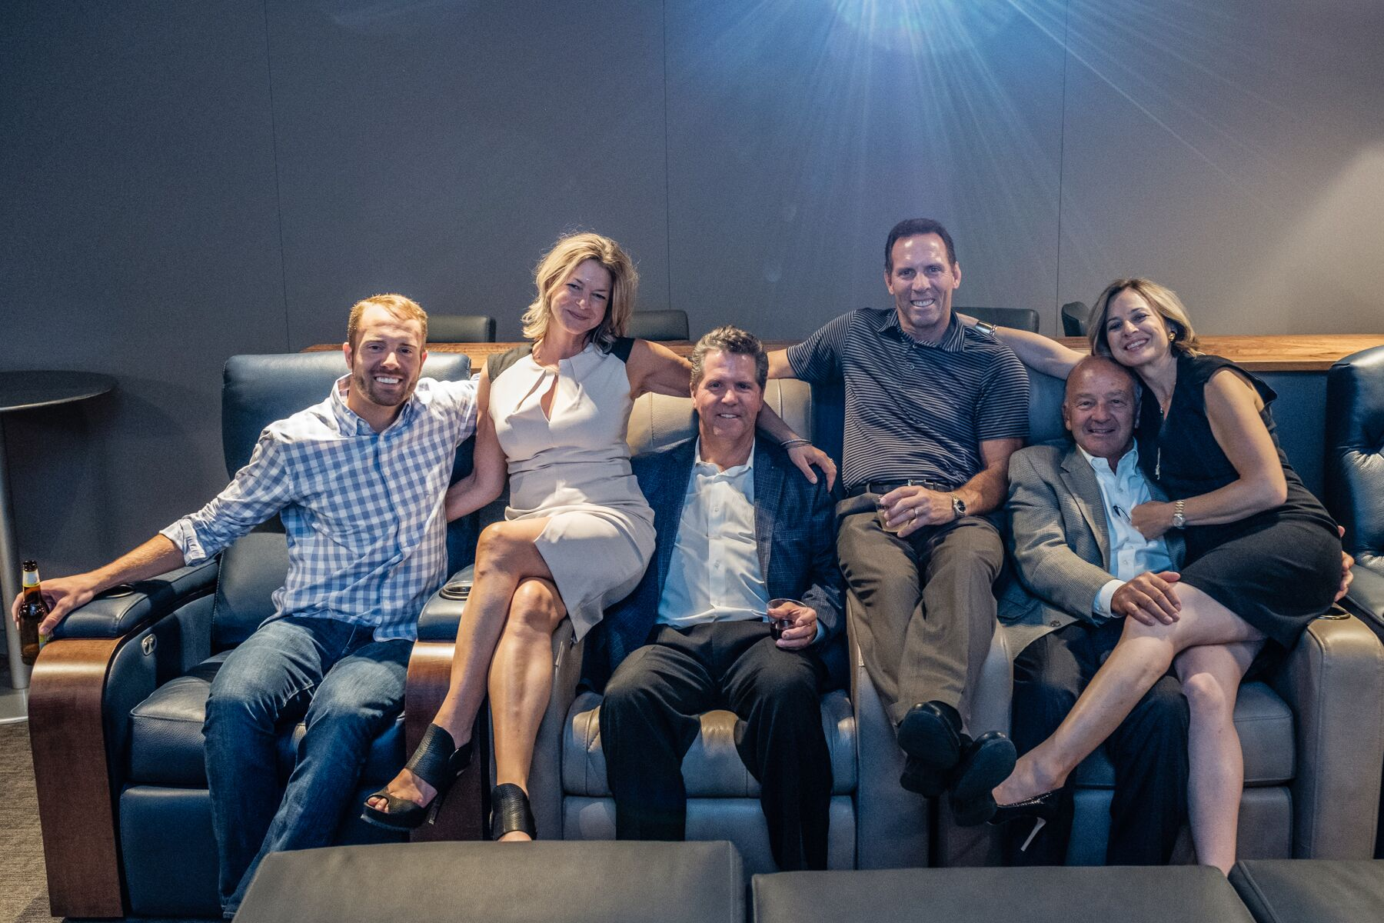
A very long road from our first appearance in the Mart for Design Summit 2013. A moment to savor with our family, who came from near and far to share this incredibly special evening with us. This is what a dream come true looks like.

Our Trends
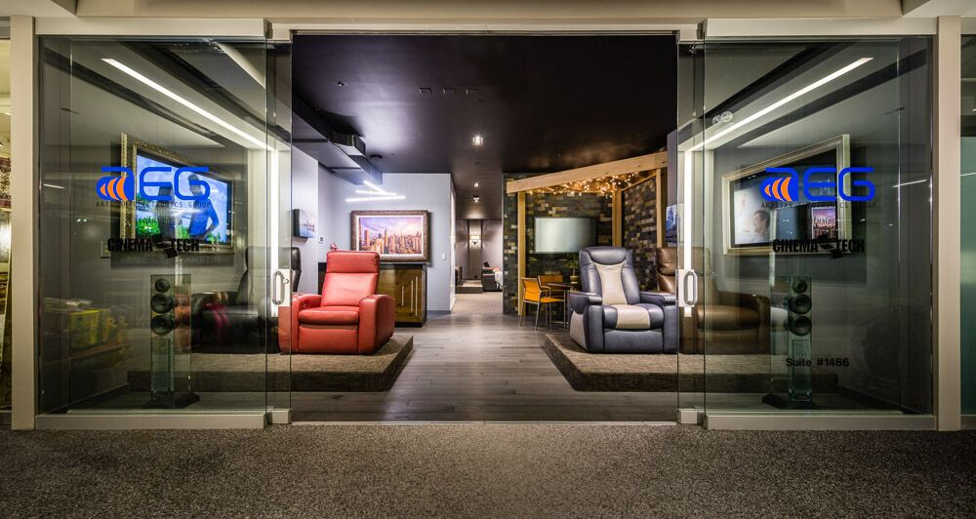

When I share this image with people, most ask if it is a rendering. It is not. This is a photograph of the showroom that AEG has built in suite 1486 of the Merchandise Mart.
It is beautiful.
If there is one thing that we have learned about doing business in the Mart, it is that the caliber of the customer who shops here is everything we hoped they would be.
At the writing of this paper, our doors have been open for almost 14 months, and we are on our way to a 300% increase in the size of our business in our first full year in the building.
The people who find their way to the 14th floor are qualified customers. We see and indulge the occasional looky-loo, but for the most part, we believe that everyone who walks into our showroom is a qualified prospect to purchase the very best of what we sell. This is where the most discerning customers shop.

Our Future
The market void we believed existed in the category of high-end custom theater seating is everything we thought it might be, and quite possibly more. In only our first year in business in the Mart, we have customers coming to us from all over the country to work with them on theater seating. Because we are on a furniture floor, our seating sales took hold immediately. We believed that there is a customer who wants a best-in-class theater seat, as much as they desire and have the purchasing power to enjoy best-in-class anything.
With our own years of experience as a residential theater builder without a theater seating strategy, we have come to understand that there are very few theater builders who understand the business opportunity that exists with best-in-class theater seating. We believe that we have flipped the equation for the way that we can sell high-end home theaters. In our opinion, we believe that most of the sellers of high-end residential theaters focus all but entirely on the electronics side of the equation, and then find themselves without a solution for quality seating, and what that can mean for both their customer and their bottom line. Many in our business have the confidence to sell an $8,000 projector, but for some reason not a theater chair at that price point, let alone a dozen of them. This is where the opportunity lies, and we have put ourselves in a tremendous position to capitalize on that opportunity.
As we commemorated our first year in business, we took stock of what we had learned and how that can help us better refine how we move forward. We know that theater seating is going to be a big part of our business and we know that there is a significant long-term market opportunity for us to be successful in this area. Knowing that there will be many individuals from outside of the Chicago market who are building quality theaters but who don’t have a seating strategy is something which can extend our brand’s reach from coast-to-coast.
More importantly, we see being the next greatest opportunity for growth is to establish AEG as a best-in-class theater builder. Soup-to-nuts; stem-to-stern. The theater demonstration we provide with our 5.2.6 Atmos system in the showroom is thunderous and precise. The probability of our demonstration being the most impressive residential theater experience that any of our visitors have ever seen is all but a certainty. People will know that they have seen what state-of-the-art home cinema is all about. We want people to be coming to us for our reputation as theater builders and we are beginning to see that happen with increasing regularity. In our previous 15 years in business, we would get a good theater project every couple of years. Right now, we have three in the works and we are seeing the quality of these theaters improve with each one that we build.

The better a theater you can show…
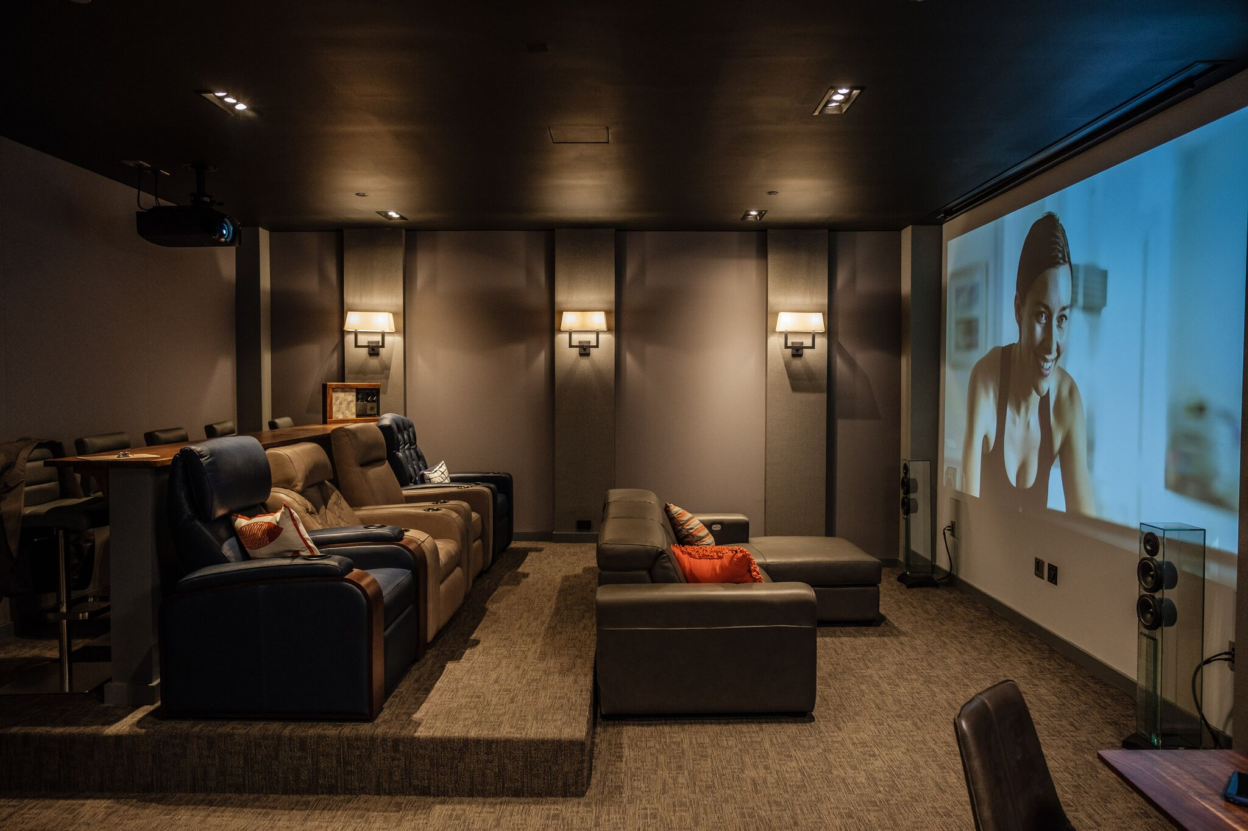

We believe that the theater we built is in fact every bit as stunning as the rendering Suzann Nordstrom drew for us. Better in many ways.
When you look at this image of the AEG Theater there are some key things that you don’t see. Most notably on that list is a Sony 4k ultra-short-throw projector. In the end, we simply were not able to make the deal with Sony work. Speaking as objectively as I can, I felt that Sony wanted way too much say in the overall look and presentation of our showroom for amount of skin they were willing to put in the game.
What you do see is a spectacular 165” 4k image on the most highly-engineered, “standard wall” ever built. As the chief engineer on this specific element, I am very proud of the quality of image that we can produce without a screen. That said, we are very much in the screen business and tell everyone who is wowed by our current presentation that our video demonstration would be even more stunning if we were to show that image on a best-in-class 4k-certified acoustically-transparent screen. As Steve Rainey puts it very succinctly, “We’re not selling paint.”
Because we no longer have a specific reason to show a front projection image on the wall, we think the time has come to install a permanent-fixed screen on the front wall. We believe the best screen choice for this application is the Draper Profile+ screen in the borderless configuration. The subtlety of using a grey screen surface on a grey wall will be a fabulously subliminal approach to continuing our “where performance meets aesthetics” mantra. For as stunning as our theater is, we know that it will be even better if we use an ISF-Certified 4K screen. If that screen can give us the ability to improve an already spectacular demonstration, we are fully confident that we will secure more top-end theater projects, every one of which will include a best-in-class Draper screen.
We believe that we’ve been right about pretty much every element of our strategy to date. I’m confident that we will be right about this as well and hope that Draper will feel the same way.
As an ending note, in only two years’ time, we went from having a small sponsorship in the ASID Illinois Celebration of Design competition to standing at the podium accepting the award for First Place in the category of Innovation in Design and Technology. There has been nothing that has been easy about becoming the first ever electronics showroom in the Merchandise Mart, but as the saying goes, “If it was easy, everyone would be doing it.”
Thank you for giving me the opportunity to tell this story.

